
RAMAIAH
Institute of Technology
USN | 1 | M | S

(Autonomous Institute, Affiliated to VTU)
(Approved by AICTE, New Delhi & Govt. of Karnataka) Accredited by NBA & NAAC with ‘A’ Grade

MAKEUP EXAMINATIONS – JULY 2019

Course & Branch | : | B.E. : Common to all branches | Semester | : | II
Subject | : | Engineering Mathematics - II | Max. Marks | : | 100
Subject Code | : | MA21/MAT201 | Duration | : | 3 Hrs

Instructions to the Candidates:
- Answer one full question from each unit.

 |  | UNIT- I
1. | a) | Find 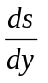 for 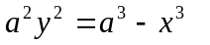at 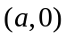 | CO1 | (02)
 | b) | Prove that the radius of curvature of the curve 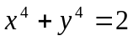 at the point (1,1) is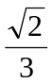. | CO1 | (04)
 | c) | Expand 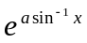 in ascending powers of upto the term containing 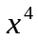. | CO1 | (07)
 | d) | The temperature T at any point 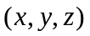in space is 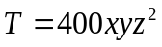. Find the highest temperature on the surface of the unit sphere 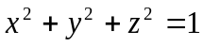. | CO1 | (07)
2. | a) | State Maclaurin's series for the function of one variable. | CO1 | (02)
 | b) | Show that 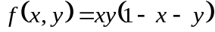 is maximum at the point 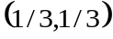. | CO1 | (04)
 | c) | Obtain the expression for radius of curvature in polar form. | CO1 | (07)
 | d) | Expand 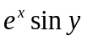in powers of and upto second degree terms. | CO1 | (07)
 |  | UNIT- II
3. | a) | Define orthogonal trajectories. | CO2 | (02)
 | b) | Solve 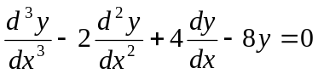. | CO2 | (04)
 | c) | A voltage 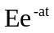 is applied to a circuit of inductance and resistance 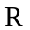.Show that the current at time is 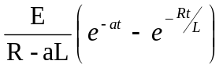 if initial current is zero. | CO2 | (07)
 | d) | Solve 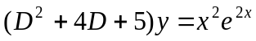. | CO2 | (07)
4. | a) | Write the DE of the closed circuit involving R and C along with a voltage source E. | CO2 | (02)
 | b) | Find the orthogonal trajectories of the family of asteroids 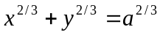. | CO2 | (04)
 | c) | Water at temperature 100⁰ C cools in 10 minutes to 88⁰ C in a room of temperature 25⁰ C. Find the temperature of water after 20 minutes. | CO2 | (07)
 | d) | Solve 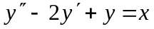 given 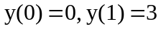. | CO2 | (07)
 |  | UNIT- III
5. | a) | Solve . | CO3 | (02)
 | b) | Solve . | CO3 | (04)
 | c) | A condenser of capacity C discharged through an inductance L and resistance R in series and the charge q at time t satisfies the equation , given that L = 0.25 henries, R = 250 ohms, C = 2×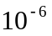 farads, and that when t = 0, charge q is 0.002 coulombs and the current . Obtain the value of q in terms of t. | CO3 | (07)
 | d) | Solve the differential equation , by the method of variation of parameters. | CO3 | (07)
6. | a) | and then prove that . | CO3 | (02)
 | b) | Solve . | CO3 | (04)
 | c) | Solve the differential equation , by the method of variation of parameters. | CO3 | (07)
 | d) | Solve: . | CO3 | (07)
 |  | UNIT- IV
7. | a) | Prove that 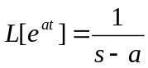. | CO4 | (02)
 | b) | Define unit – step function and hence find its Laplace transform. | CO4 | (04)
 | c) | Evaluate the following: i) 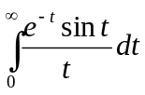 ii) 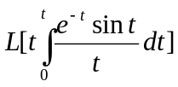. | CO4 | (07)
 | d) | Prove that 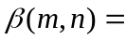. | CO4 | (07)
8. | a) | Define Dirac-Delta function. | CO4 | (02)
 | b) | Evaluate 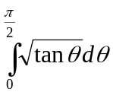, using Gamma function. | CO4 | (04)
 | c) | Express the function f (t) = 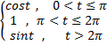  in terms of the unit step function and hence find its Laplace transform. | CO4 | (07)
 | d) | Evaluate: i) 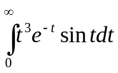 ii) 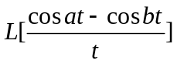. | CO4 | (07)
 |  | UNIT- V
9. | a) | Define a periodic function with an example. | CO5 | (02)
 | b) | Solve the initial value problem using Laplace transforms. | CO5 | (04)
 | c) | State and prove convolution theorem. | CO5 | (07)
 | d) | Evaluate: 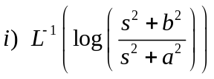 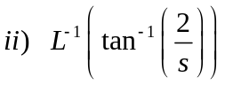. | CO5 | (07)
10 | a) | Write the formula to find 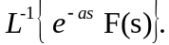 | CO5 | (02)
 | b) | Verify convolution theorem for the pair of functions  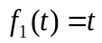 and 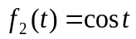. | CO5 | (04)
 | c) | Find the Laplace transform of the function of period 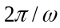 defined by: 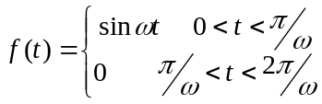. | CO5 | (07)
 | d) | The coordinates 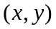of a particle moving along a plane curve at any point , are given by . If at 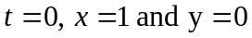 then show by using Laplace transforms that the particle moves along the curve 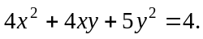 | CO5 | (07)

****************

